**LedCharger Module Description Document**

**1. Charging Indicator LED Control**

**1.1.Internal Structure Diagram**

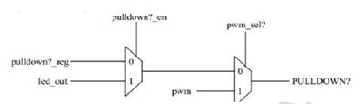

Figure 1 Charging indicator LED control diagram

As shown in the figure above, there are three input sources for the LED control signal: PWM pulse signal, LED clock generator, and pulldown register.

**1.2.Function Description**

GPIOA0 can be configured as a regular GPIO pin or in three other modes: pull-down current source, charging indicator (flashing during charging, on/off when charging is complete), and PWM output.

**1.2.1. Pull-down Current Source**

GPIOA0 is different from the common GPIOA. When it is configured as a pull-down current source type, it can be configured to output 1.7mA, 2.4mA and 4.1mA pull-down currents. Moreover, its pulldown1 and pulldown2 are controlled by LED modules.

**1.2.2. Charging Indication**

When GPIOA0 is configured for charging indication function, its signal value comes from the LED clock generation module. When charging is in progress, it will output a pulse signal of a certain frequency, and when charging is completed, it will output a fixed signal.

**1.2.3. PWM Output**

The GPIOA0 pin can also be configured as a PWM output type, which has the same effect as the ordinary GPIOA0 multiplexed to the PWM function.

**1.2.4. Example of Usage processes**

Set GPIOA0 as the charging indicator function. During the charging process, it will flash continuously at intervals of 1 second. It will light up when the charging is completed (if the circuit is designed to output 0, it will light up).

ChargerSetMode(15, 0);